GVP MAA – Multi-Agent Academic Assistant

¹K.Mohith, ²E.Purinima ,³K.Badraiah, ⁴T.Sandeep
Department of Computer Science and Engineering, Gayatri Vidya Parishad College for Degree and PG Courses (A), Visakhapatnam, India,
¹anilmeka@gvpcdpgc.edu.in, ²5221411142@gvpcdpgc.edu.in, ³5221411151@gvpcdpgc.edu.in,
⁴5221411133@gvpcdpgc.edu.in , ⁵5221411205@gvpcdpgc.edu.in

ABSTRACT

Educational institutions handle various types of academic data such as attendance, marks, schedules, and student records. In many cases, traditional systems are manual or lack advanced automation, which can lead to delays and reduced efficiency.

GVP-MAAA (Multi-Agent Academic Assistant) is a web-based system developed to simplify academic management using a multi-agent approach and role-based dashboards. The platform supports attendance tracking, performance monitoring, and early identification of students who may require academic support.

It provides centralized data access, timely notifications, and basic analytical insights to assist administrators and faculty members in decision-making. The system aims to improve transparency, reduce manual workload, and enhance overall academic management within the institution.

- INTRODUCTION

Educational institutions handle various routine academic activities such as recording attendance, updating marks, preparing schedules, and generating reports. In many cases, these activities are managed manually or through separate systems that are not well connected. This can result in delays, data duplication, and limited access to real-time information.

Students often find it difficult to continuously monitor their academic progress, while faculty members spend significant time on administrative work instead of academic guidance. To overcome these issues, the project *GVP-MAAA* is developed as a web-based academic management system.

The proposed system uses a multi-agent structure along with role-based dashboards to organize and automate academic tasks. It provides features such as attendance monitoring, performance analysis, notification management, and chatbot-based assistance within a single integrated platform.

THEORETICAL BACKGROUND

Earlier studies have examined the use of multi-

agent architectures in academic environments, particularly for advising systems and course recommendation support. Research has also focused on AI-based chatbots designed to assist students by answering queries related to schedules, attendance, and academic procedures.

Although these approaches demonstrate the usefulness of intelligent systems in education, most of them function as separate solutions.

The proposed GVP-MAAA system brings these concepts together within a single platform. It combines coordinated multi-agent components with chatbot assistance, performance analysis, risk identification, and dashboard-based monitoring to create a more connected academic management solution.

LITERATUREREVIEW
Some studies used *multi-agent systems* for academic advising and course planning. These systems help students choose subjects and manage schedules. Another study developed an *AI-based chatbot* to answer student queries about timetables and attendance. However, these solutions focus on limited tasks and do not provide a complete academic management system. The proposed *GVP-MAAA* integrates multi-agent coordination and chatbot support to improve academic management.

SYSTEM ARCHITECTURE:

4.1. System Architecture Diagram

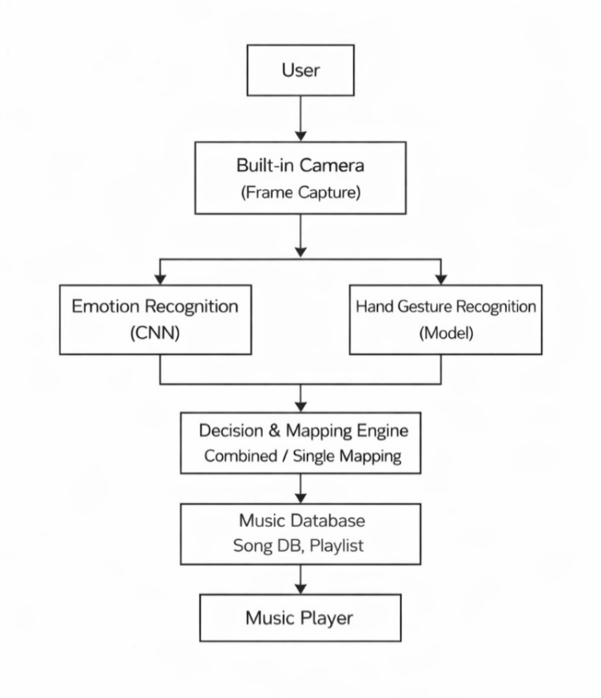

Figure 4.1: System Architecture of GVP-MAAA*

This diagram illustrates the overall structure of the system, including the frontend interface, backend server, multi-agent modules, and database. It shows how different components interact to provide academic services for students, faculty, and administrators. The architecture ensures smooth communication between modules and efficient management of academic data.

4.2. Sign in Page

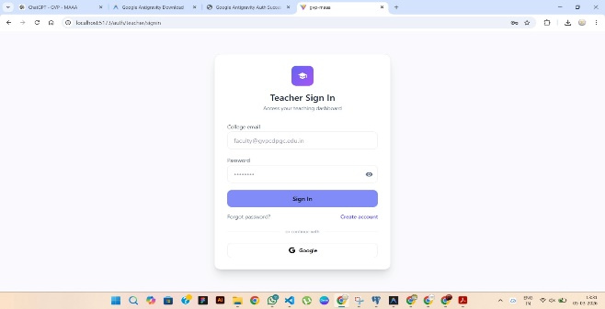

Figure:4.2 Teacher Sign in Page

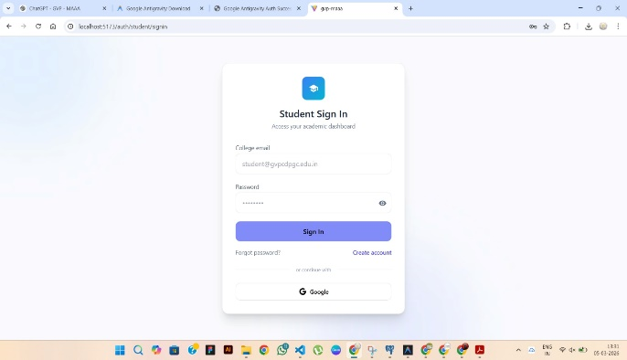

Figure 4.2: Student Sign in Page

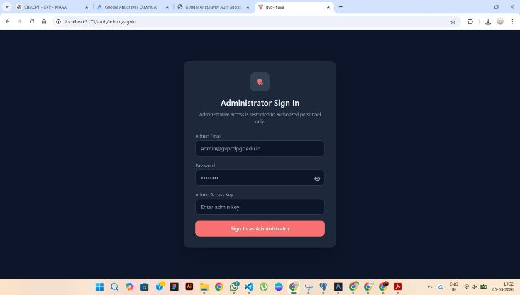

Figure 4.2: System Sign in Page

The login page allows authorized users to access the system using their credentials. Based on the login role (student, faculty, or admin), the system redirects the user to the appropriate dashboard with relevant functionalities.

4.3. Admin Dashboard

Figure 4.3: Administrator Dashboard

The admin dashboard provides centralized management of the academic system. Administrators can monitor student and faculty data, manage schedules, send announcements, and generate reports for institutional insights.

44. Student Dashboard

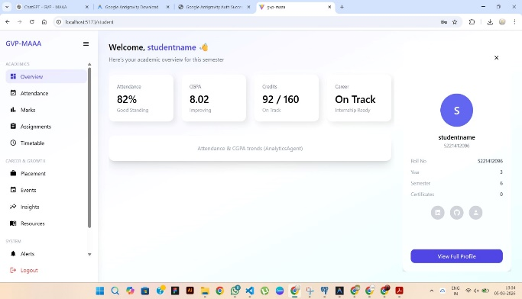

Figure 4.4.: Student Dashboard

The student dashboard displays personal academic information such as attendance, marks, timetable, and notifications. It enables students to easily track their academic progress and receive updates from faculty or administration.

4.5. Faculty Dashboard

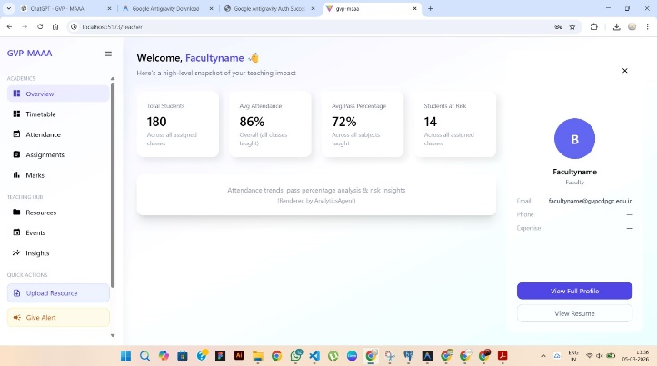

Figure 4.5.: Faculty Dashboard

The faculty dashboard allows instructors to manage academic data. Faculty members can upload attendance, enter marks, share study resources, and monitor student performance through analytical insights.

4.6. Attendance Management Table

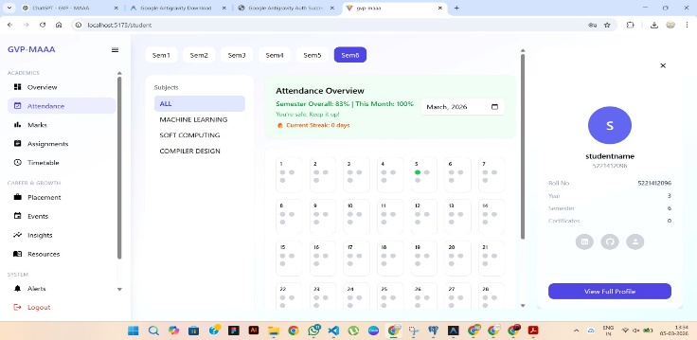

Figure 4.6.: Attendance Management Module

This module displays attendance records of students in tabular format. Faculty members update attendance regularly, and the system calculates attendance percentages automatically for monitoring academic eligibility.

4.7. Marks / Performance Table

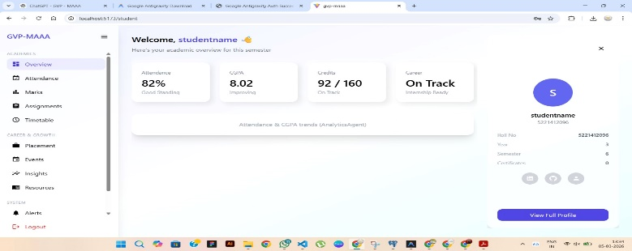

Figure 4.7.: Student Marks Management

This table stores subject-wise marks of students. The stored data is used by the analytics module to evaluate student performance and generate reports.

4.8. Notification / Alert System

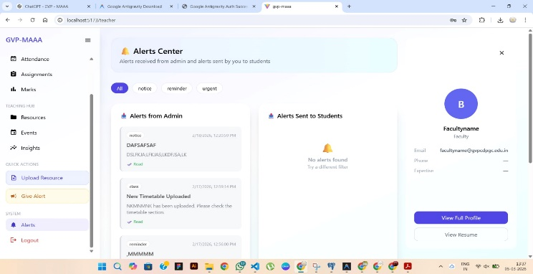

Figure 4.8.: Notification Module

The notification module sends automated alerts related to attendance shortage, exams, announcements, and events. This improves communication between students, faculty, and administrators.

5. DATA ACQUISITION AND PROCESSING:

Data acquisition in the GVP-MAAA system involves collecting academic data such as attendance, marks, timetables, and announcements from faculty, administrators, and students through the web platform.

After collection, the system processes the data by cleaning incorrect or missing values and organizing it into a structured format. The processed data is stored in the database and used for generating analytics, performance reports, and automated notifications for students and faculty.

6. METHODOLOGY:

The GVP-MAAA system is designed using a multi-agent framework to manage academic activities efficiently. Users log in through secure authentication based on their roles student, faculty, or administrator. Access to features is provided according to user responsibilities.

Faculty members enter attendance and marks, while students can view their records and academic updates. The system checks and organizes the data before processing. Academic performance is then examined to identify patterns such as low attendance or reduced marks.

